**How to use Luke**  
Open a specific directory beneath the Case’s index dataStore, e.g.:  
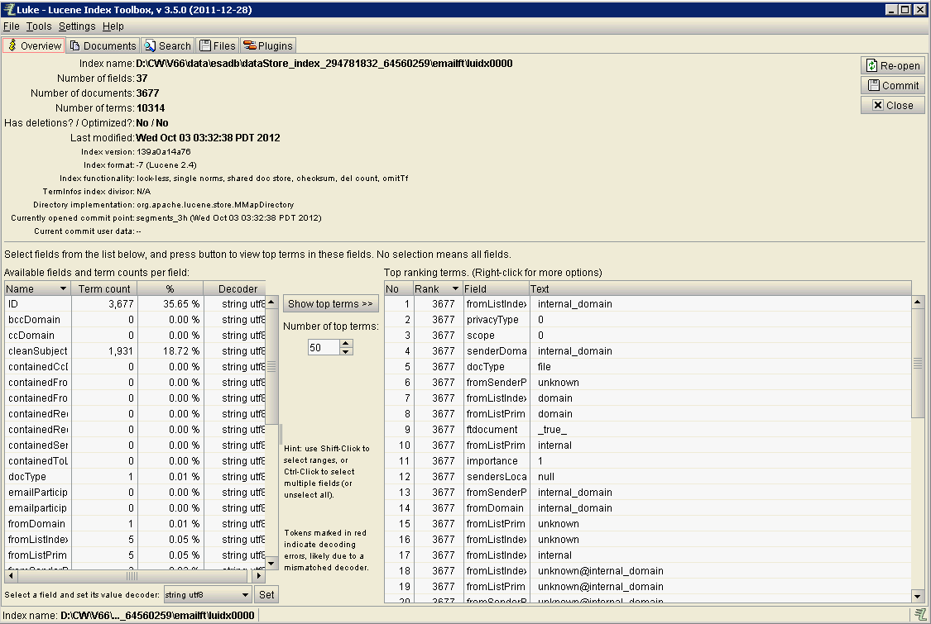  
Search for a PDF loose file that you know about:  
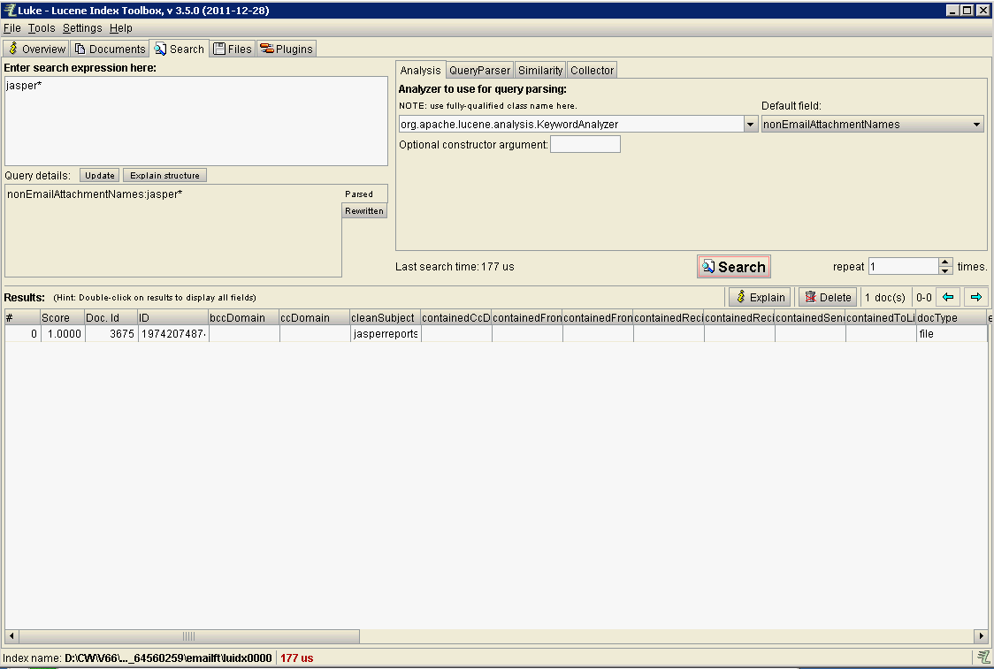  
  
Note the use of the ‘*’ wild-card, and that I also had to select “nonEmailAttachmentNames”, before I clicked the “Search” button.  
  
If you double-click this line, you will see full details:  
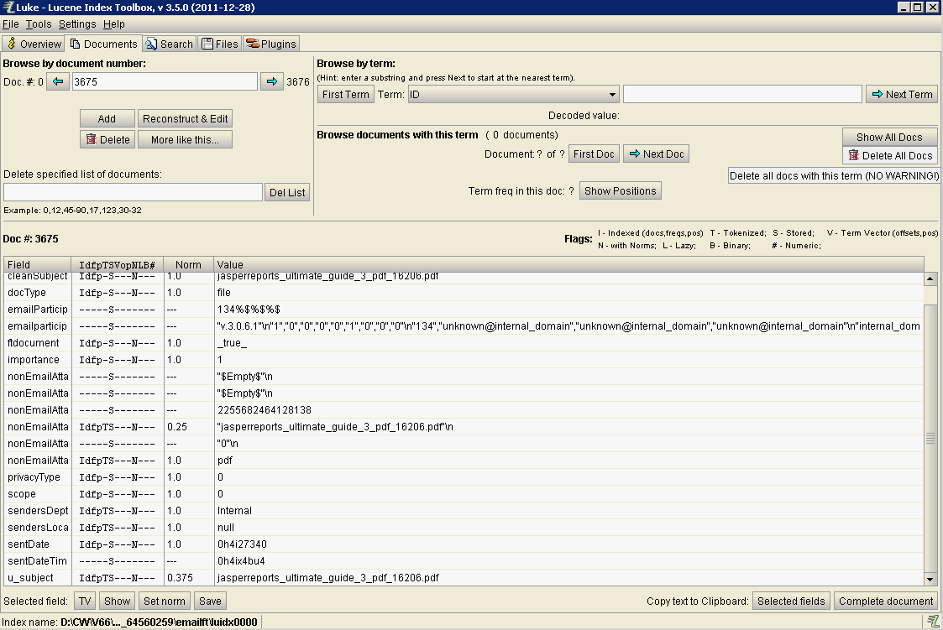  
  
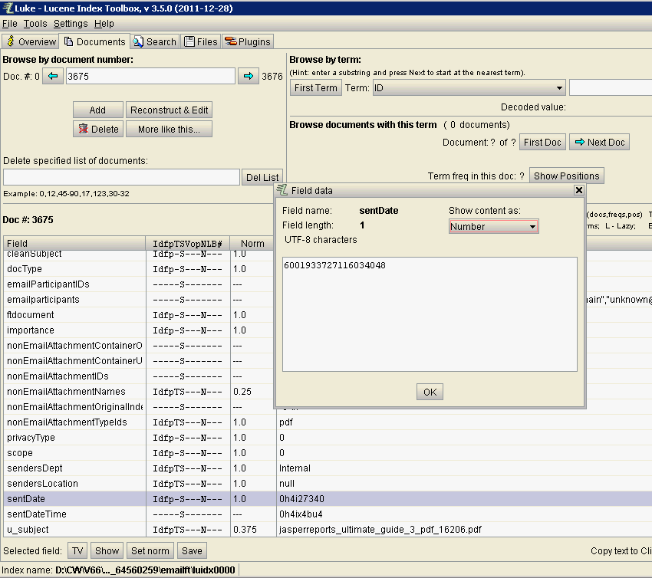  
  
**END**